**Nitride film 3 MT-455**

Ragula Bhoopal

20ETMM11

Group-2

**Aim:** To determine crystallite size and lattice strain for the given data.

**Procedure:**

Given the instrumental broadening value,

Gaussian equation 

 where, $η=S\text{train in the material}$ $$\text{L= Crystallite Size} \\ \text{k=0.94}$$

$λ=0.154nm$

Comparing the above equation with  Where, 

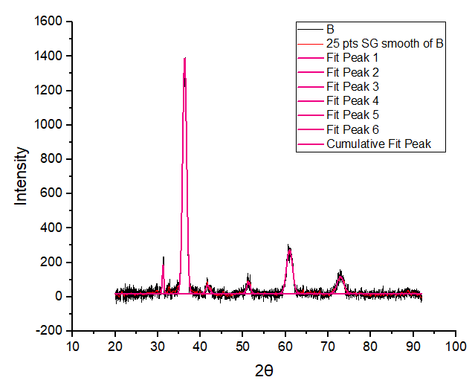

|  |  |  |  |  |  |  |  |
| --- | --- | --- | --- | --- | --- | --- | --- |
| **2θ** | **θ(rad)** | **Bo(fwhm)** | **Bo(rad)** | **Bo2** | **Bi(deg)** | **Bi(rad)** | **Bi2** |
| 31.23024 | 0.272535 | 0.40573 | 0.007081 | 5.01E-05 | 0.045 | 0.000785 | 6.17E-07 |
| 36.29897 | 0.316768 | 1.10047 | 0.019207 | 0.000369 | 0.045 | 0.000785 | 6.17E-07 |
| 41.76266 | 0.364448 | 1.10718 | 0.019324 | 0.000373 | 0.045 | 0.000785 | 6.17E-07 |
| 51.3042 | 0.447714 | 1.01079 | 0.017642 | 0.000311 | 0.045 | 0.000785 | 6.17E-07 |
| 60.93761 | 0.531781 | 1.65249 | 0.028841 | 0.000832 | 0.045 | 0.000785 | 6.17E-07 |
| 72.90834 | 0.636245 | 1.89106 | 0.033005 | 0.001089 | 0.045 | 0.000785 | 6.17E-07 |

|  |  |  |  |
| --- | --- | --- | --- |
| **Br2=Bo2-Bi2** | **Br** | **Brcosθ** | **sinθ** |
| 4.95E-05 | 0.007038 | 0.006778 | 0.269174 |
| 0.000368 | 0.019191 | 0.018236 | 0.311497 |
| 0.000373 | 0.019308 | 0.01804 | 0.356434 |
| 0.000311 | 0.017624 | 0.015887 | 0.432906 |
| 0.000831 | 0.028831 | 0.024849 | 0.507069 |
| 0.001089 | 0.032996 | 0.02654 | 0.59418 |

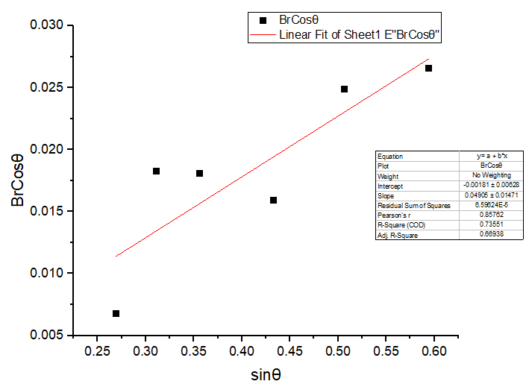

|  |  |
| --- | --- |
| Equation | y = a + b*x |
| Plot | BrCosθ |
| Weight | No Weighting |
| Intercept | -0.00181 ± 0.00628 |
| Slope | 0.04905 ± 0.01471 |
| Residual Sum of Squares | 6.59624E-5 |
| Pearson's r | 0.85762 |
| R-Square (COD) | 0.73551 |
| Adj. R-Square | 0.66938 |

$$b=Slope=η \\ a=Intercept=\frac{kλ}{L} \\ Therefore, η=0.04905 \\ \frac{kλ}{L}=0.00447 \\ L=\frac{kλ}{0.00447} \\ L=\frac{0.94×0.154}{0.00447} \\ L=32.3847\text{ nm}$$

**Result**

$$η=S\text{train in the material=}0.04905 \\ \text{L= Crystallite Size}=32.3847 \text{nm}$$